PHASE 4 – Automatic Ticket Classification
After configuring the trigger, create conditions in Flow Designer to identify keywords from the Short Description and automatically assign the appropriate Category and Subcategory.
Activity 1: Wi-Fi Issue Classification
- Under Actions, select Flow Logic.
- Select If condition.
- Enter a condition label such as:
  - SD is WiFi or Network
- Add the following conditions:
  - Short description → Contains → WiFi
  - Short description → Contains → Network
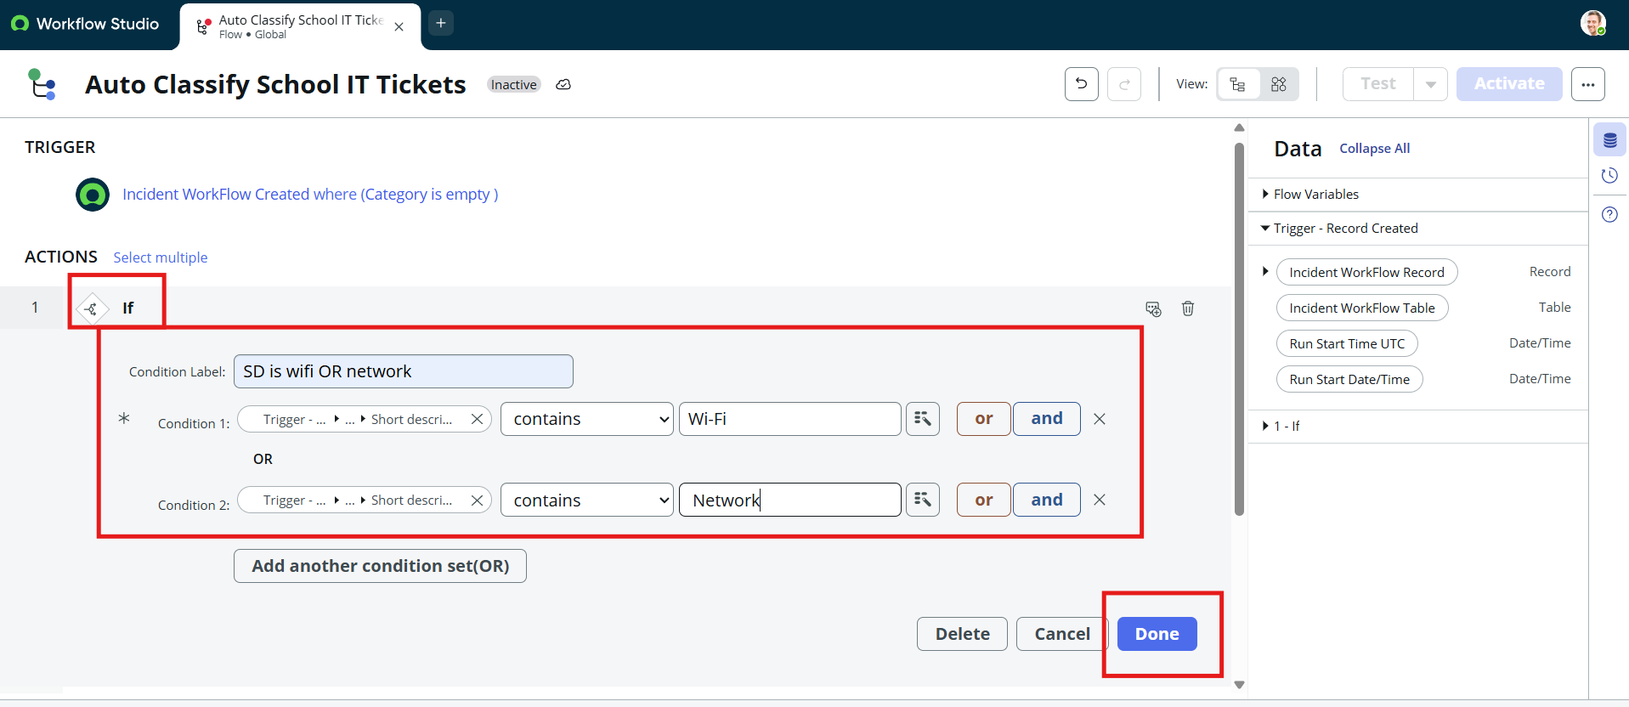
- Click Done.
- Click Action and select Update Record.
- In the Record field, select the current incident record using the data pill picker.
- Set:
  - Category: Network
  - Subcategory: WiFi
- Click Done.

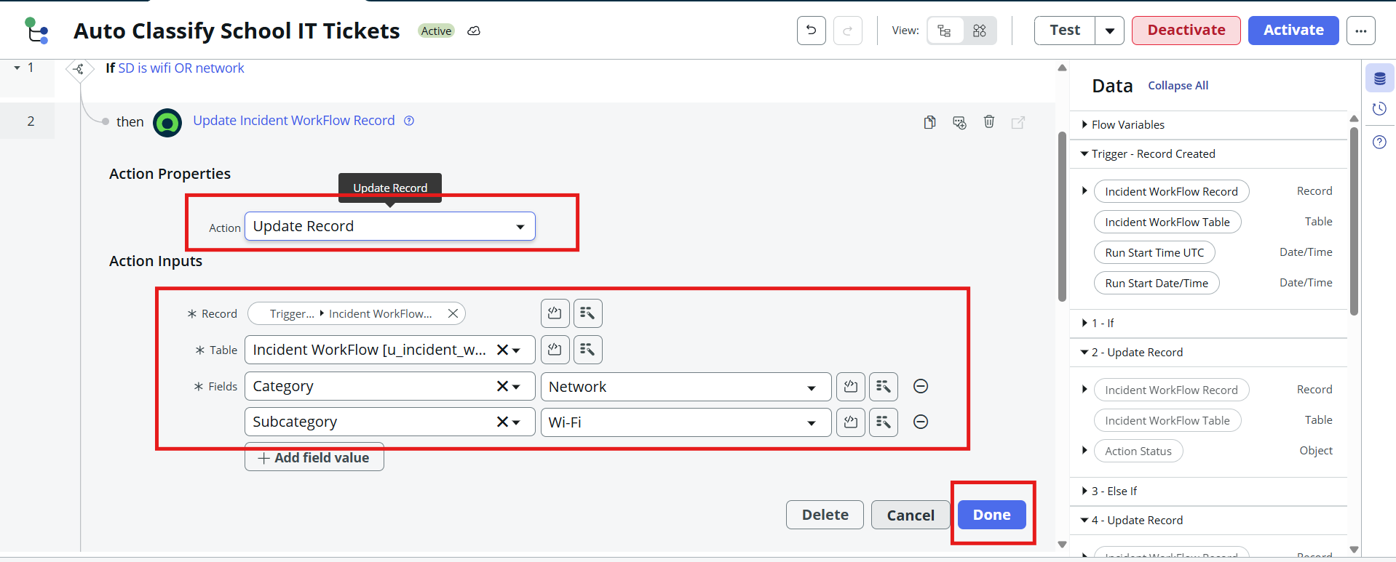
Activity 2: Projector Issue Classification
- Select Else If condition.
- Enter a condition label such as:
  - SD is Projector or Hardware
- Set the condition:
  - Short description → Contains → Projector
- Click Done.
- Select Update Record.
- Set:
  - Category: Hardware
  - Subcategory: Projector
- Click Done.
Activity 3: Password/Login Issue Classification
- Select another Else If condition.
- Enter a condition label such as:
  - SD is Forgot Password
- Add the conditions:
  - Short description → Contains → Password
  - Short description → Contains → Login
- Click Done.
- Select Update Record.
- Set:
  - Category: Access
  - Subcategory: Forgot Password
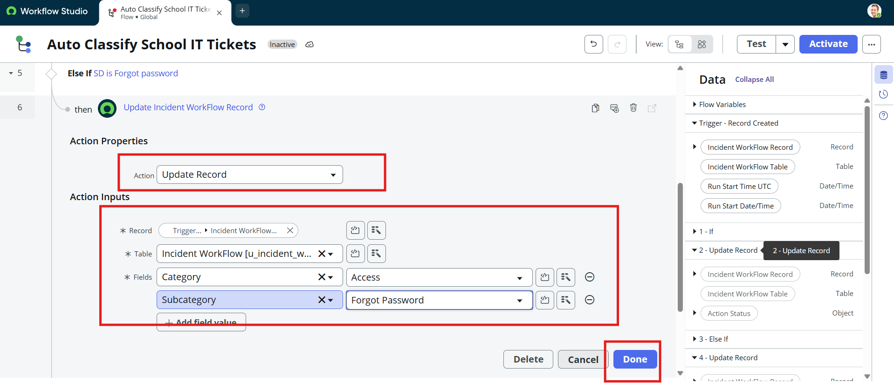
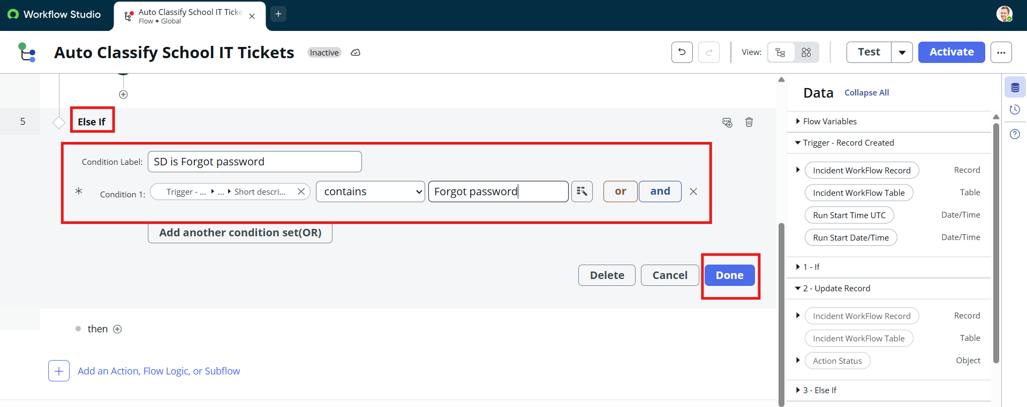
- Click Done
Activity 4: Slow Computer Classification
- Select another Else If condition.
- Enter a condition label such as:
  - SD is Performance
- Add the conditions:
  - Short description → Contains → Slow
  - Short description → Contains → Hanging
- Click Done.
- Select Update Record.
- Set:
  - Category: Performance
  - Subcategory: Slow Computer
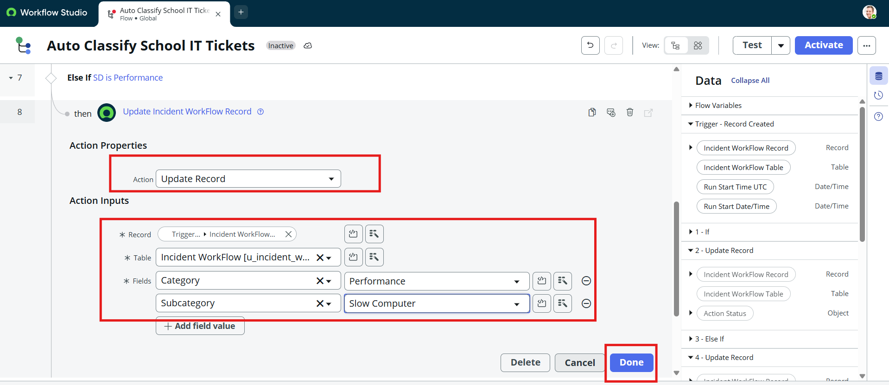
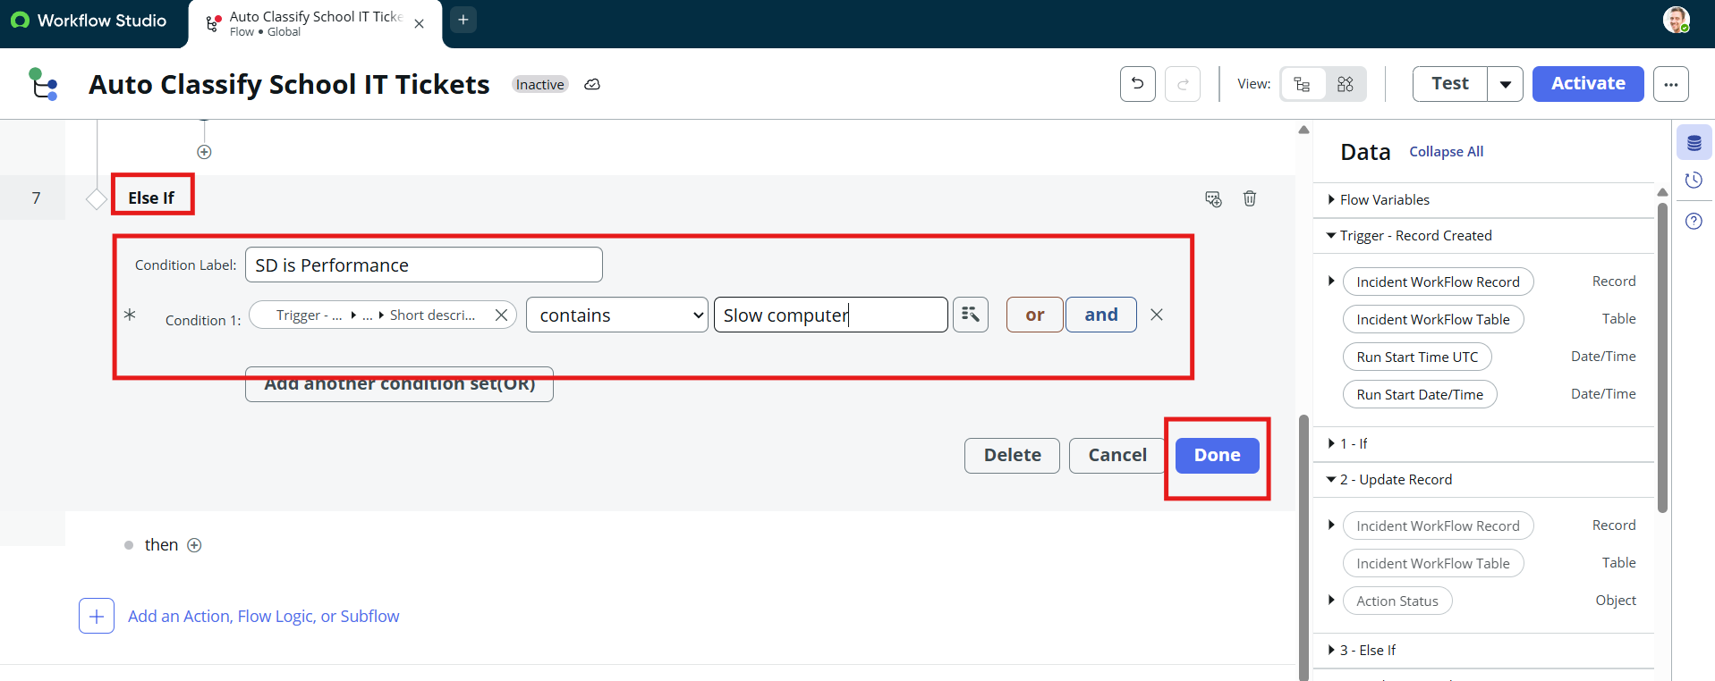
- Click Done.

